Breed: Morgan Sex: Stallion Age: 8

Height: 14-3 H

Horsenality: Right Brain Introvert/Extrovert Spirit Level: Low-Medium

Training Status: Groundwork - Beginning

Background: Stetson came to Spirit Horse as a 5 year old. He was owned by a person who bred foundation Morgans, and Stetson was her future breeding stallion. As far as we know, he was only bred once, and sired a gorgeous and talented palomino mare adopted by a Parelli Professional. Stetson’s owner was critically ill, and so we agreed to take him.

General Observations: Stetson is a truly right-brain horse. He needs people to take things very slowly, but when he becomes extroverted, his pattern needs to be interrupted. He is very sweet and wants to please, but needs a good deal of confidence building. Stetson would be well suited for just about any discipline, as long as he was given lots of time and calm direction. He will need to be gelded before adoption.

Equine Profile

Stetson

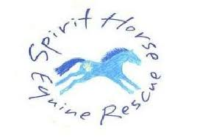

& Education Center